Types of Transmission Media

In data communication terminology, a transmission medium is a physical path between the transmitter and the receiver i.e. it is the channel through which data is sent from one place to another. Transmission Media is broadly classified into the following types:

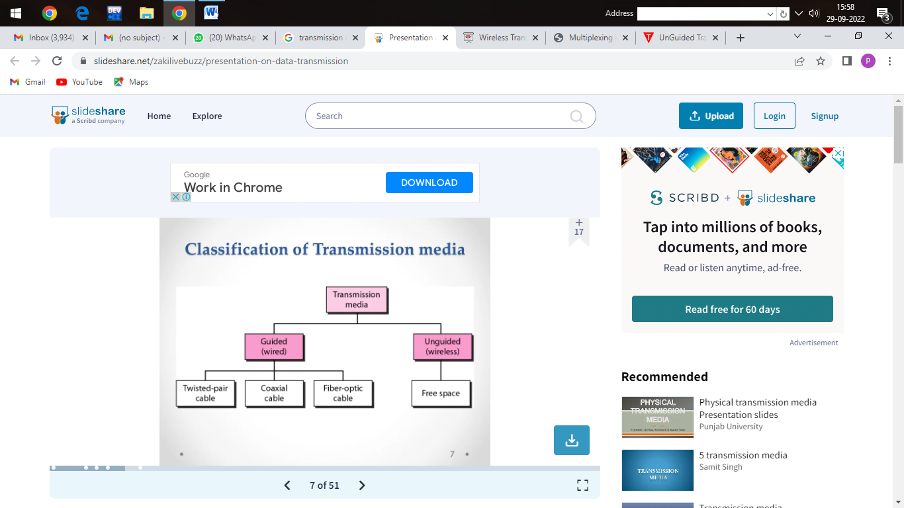

1. Guided Media: It is also referred to as Wired or Bounded transmission media. Signals being transmitted are directed and confined in a narrow pathway by using physical links.   
Features:

* High Speed
* Secure
* Used for comparatively shorter distances

There are 3 major types of Guided Media:

1.Twisted Pair Cable –

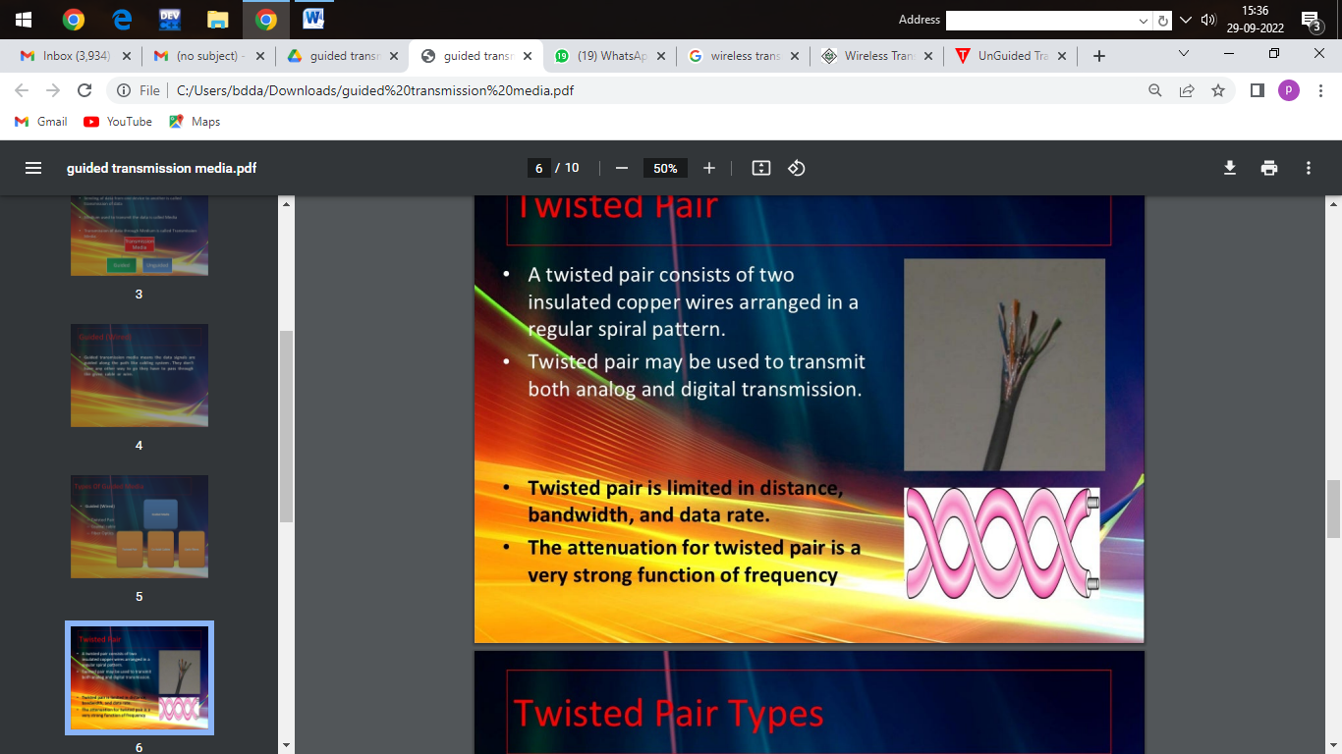

It consists of 2 separately insulated conductor wires wound about each other. Generally, several such pairs are bundled together in a protective sheath. They are the most widely used Transmission Media. Twisted Pair is of two types:

* Unshielded Twisted Pair (UTP):   
  UTP consists of two insulated copper wires twisted around one another. This type of cable has the ability to block interference and does not depend on a physical shield for this purpose. It is used for telephonic applications.

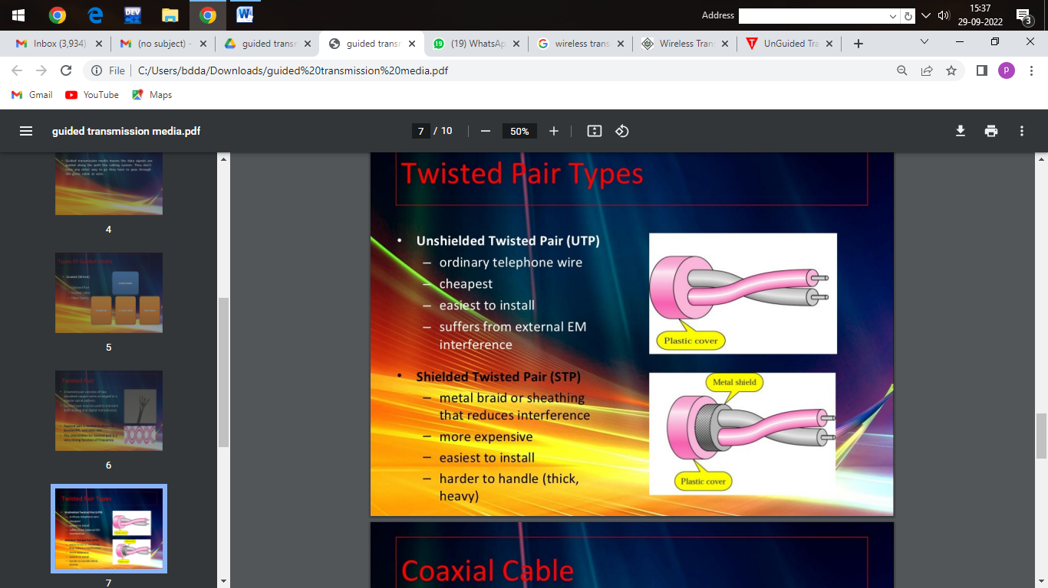

Advantages:

⇢ Least expensive

⇢ Easy to install

⇢ High-speed capacity

⇢ Susceptible to external interference

⇢ Lower capacity and performance in comparison to STP

⇢ Short distance transmission due to attenuation

* Shielded Twisted Pair (STP):   
  This type of cable consists of a special jacket (a copper braid covering or a foil shield) to block external interference. It is used in fast-data-rate Ethernet and in voice and data channels of telephone lines.



Advantages:

⇢ Better performance at a higher data rate in comparison to UTP

⇢ Eliminates crosstalk

⇢ Comparatively faster

⇢ Comparatively difficult to install and manufacture

⇢ More expensive

⇢ Bulky

(ii) Coaxial Cable –   
It has an outer plastic covering containing an insulation layer made of PVC or Teflon and 2 parallel conductors each having a separate insulated protection cover. The coaxial cable transmits information in two modes: Baseband mode(dedicated cable bandwidth) and Broadband mode(cable bandwidth is split into separate ranges). Cable TVs and analog television networks widely use Coaxial cables.

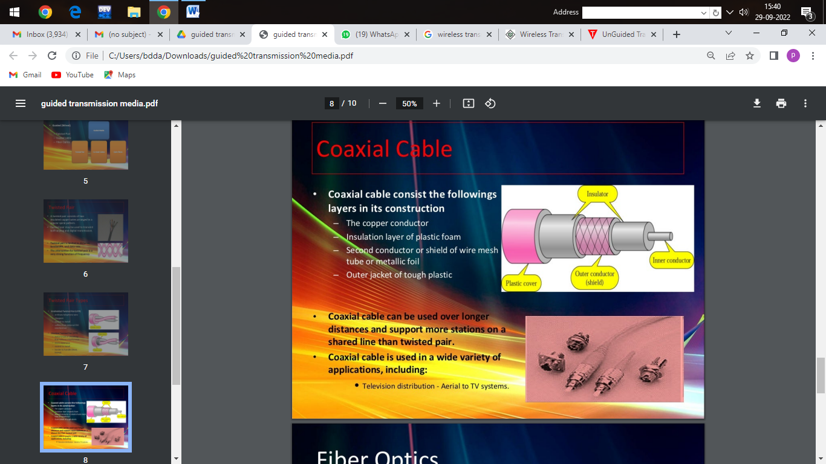



Advantages:

* High Bandwidth
* Better noise Immunity
* Easy to install and expand
* Inexpensive

Disadvantages:

* Single cable failure can disrupt the entire network

(iii) Optical Fiber Cable –   
It uses the concept of refraction of light through a core made up of glass or plastic. The core is surrounded by a less dense glass or plastic covering called the cladding. It is used for the transmission of large volumes of data.

The cable can be unidirectional or bidirectional. The WDM (Wavelength Division Multiplexer) supports two modes, namely unidirectional and bidirectional mode.

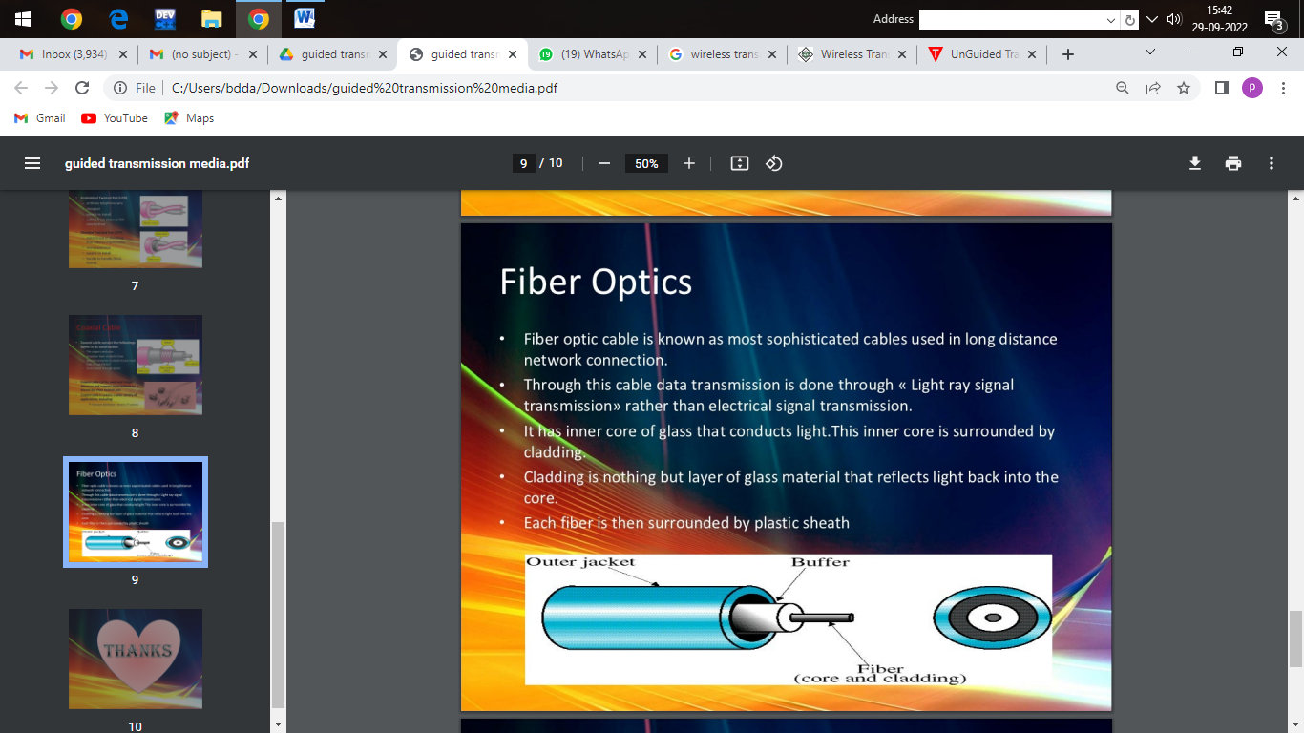

Advantages:

* Increased capacity and bandwidth
* Lightweight
* Less signal attenuation
* Immunity to electromagnetic interference
* Resistance to corrosive materials

Disadvantages:

* Difficult to install and maintain
* High cost
* Fragile

# Wireless Transmission

Wireless transmission is a form of unguided media. Wireless communication involves no physical link established between two or more devices, communicating wirelessly. Wireless signals are spread over in the air and are received and interpreted by appropriate antennas.

When an antenna is attached to electrical circuit of a computer or wireless device, it converts the digital data into wireless signals and spread all over within its frequency range. The receptor on the other end receives these signals and converts them back to digital data.

A little part of electromagnetic spectrum can be used for wireless transmission.

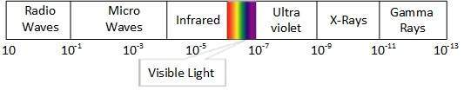

## **Radio Transmission**

Radio frequency is easier to generate and because of its large wavelength it can penetrate through walls and structures alike.Radio waves can have wavelength from 1 mm – 100,000 km and have frequency ranging from 3 Hz (Extremely Low Frequency) to 300 GHz (Extremely High Frequency). Radio frequencies are sub-divided into six bands.

Radio waves at lower frequencies can travel through walls whereas higher RF can travel in straight line and bounce back.

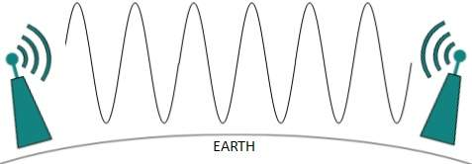

Radio waves of high frequencies are prone to be absorbed by rain and other obstacles. They use Ionosphere of earth atmosphere. High frequency radio waves such as HF and VHF bands are spread upwards. When they reach Ionosphere, they are refracted back to the earth.

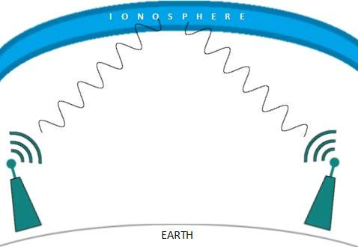

## **Microwave Transmission**

Electromagnetic waves above 100 MHz tend to travel in a straight line and signals over them can be sent by beaming those waves towards one particular station. Because Microwaves travels in straight lines, both sender and receiver must be aligned to be strictly in line-of-sight.

Microwaves can have wavelength ranging from 1 mm – 1 meter and frequency ranging from 300 MHz to 300 GHz.

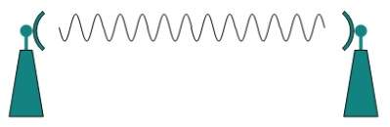

Microwave antennas concentrate the waves making a beam of it. As shown in picture above, multiple antennas can be aligned to reach farther. Microwaves have higher frequencies and do not penetrate wall like obstacles.

Microwave transmission depends highly upon the weather conditions and the frequency it is using.

## **Infrared Transmission**

Infrared wave lies in between visible light spectrum and microwaves. It has wavelength of 700-nm to 1-mm and frequency ranges from 300-GHz to 430-THz.

Infrared wave is used for very short range communication purposes such as television and it’s remote. Infrared travels in a straight line hence it is directional by nature. Because of high frequency range, Infrared cannot cross wall-like obstacles.

## **Light Transmission**

Highest most electromagnetic spectrum which can be used for data transmission is light or optical signaling. This is achieved by means of LASER.

Because of frequency light uses, it tends to travel strictly in straight line.Hence the sender and receiver must be in the line-of-sight. Because laser transmission is unidirectional, at both ends of communication the laser and the photo-detector needs to be installed. Laser beam is generally 1mm wide hence it is a work of precision to align two far receptors each pointing to lasers source.

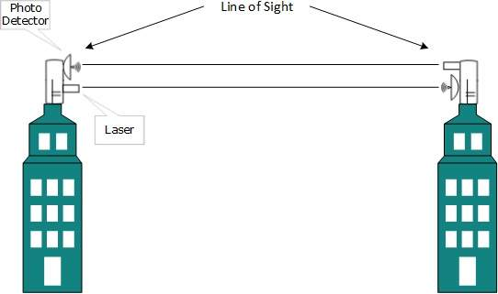

Laser works as Tx (transmitter) and photo-detectors works as Rx (receiver).

Lasers cannot penetrate obstacles such as walls, rain, and thick fog. Additionally, laser beam is distorted by wind, atmosphere temperature, or variation in temperature in the path.

Laser is safe for data transmission as it is very difficult to tap 1mm wide laser without interrupting the communication channel.